- Please enter this website: https://global.scu.edu.cn/oso/?lang=en, and click “Online Application” to apply
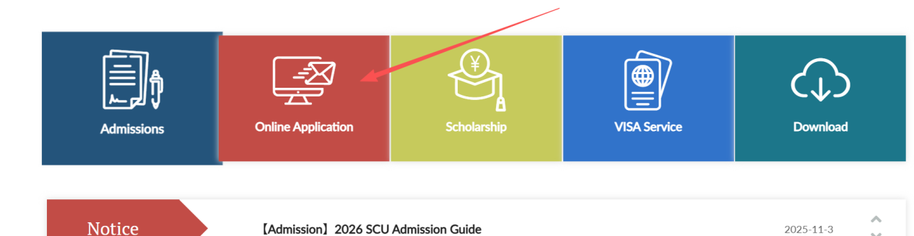

- Please click “ Register” .
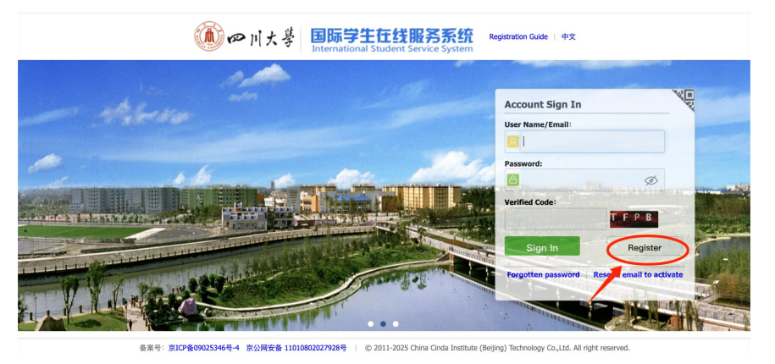
- Accept the registration agreement and fill in the registration information.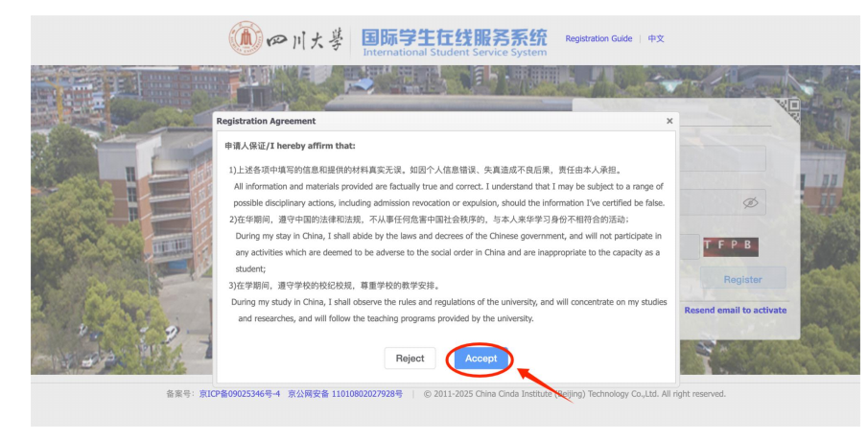

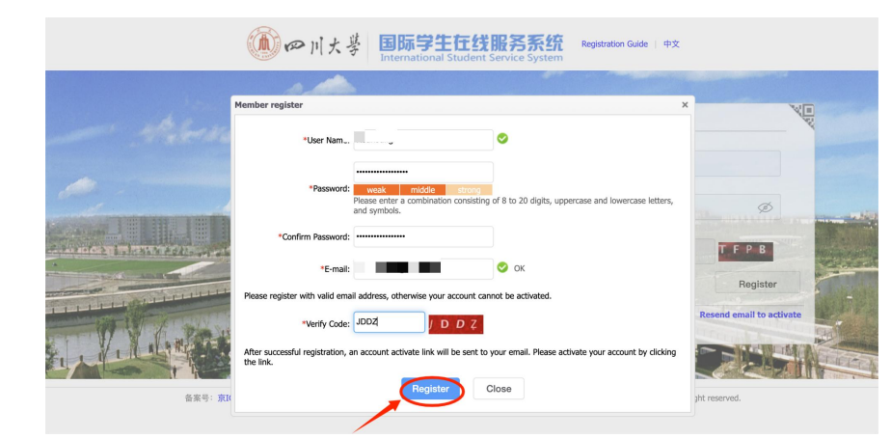

- Go to your mail box to activate the account.
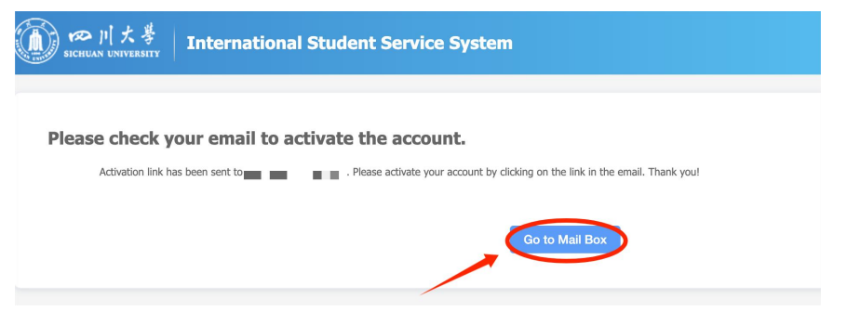
- Click the link to activate your account
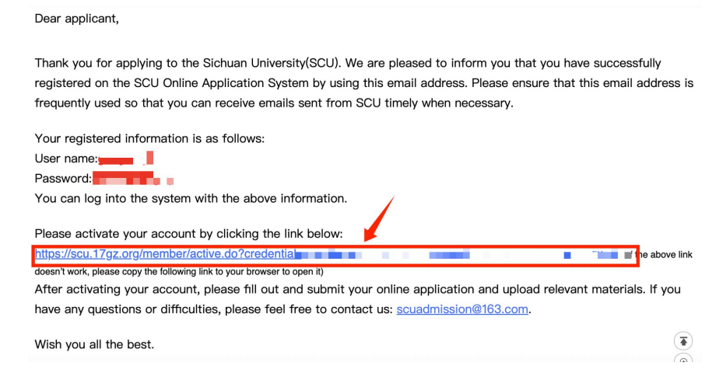

- After clicking the activation link, it will automatically jump to the interface of step 8. If there is no automatic jump, please enter https://scu.17gz.org/member/login.do, fill your user name and password to sign in.
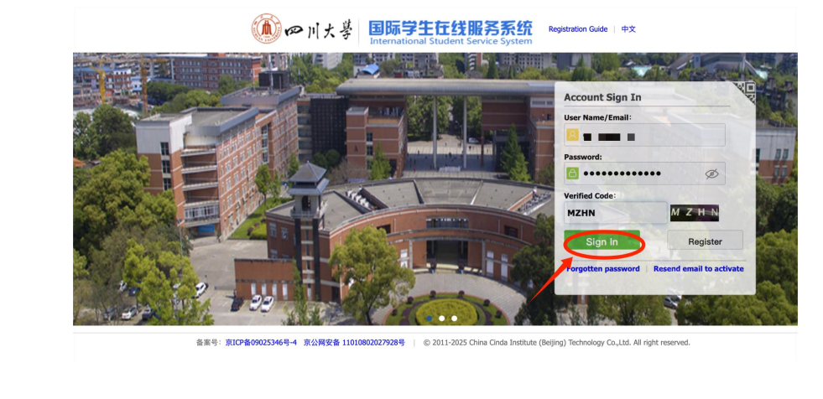、

- Click“Start Application”.
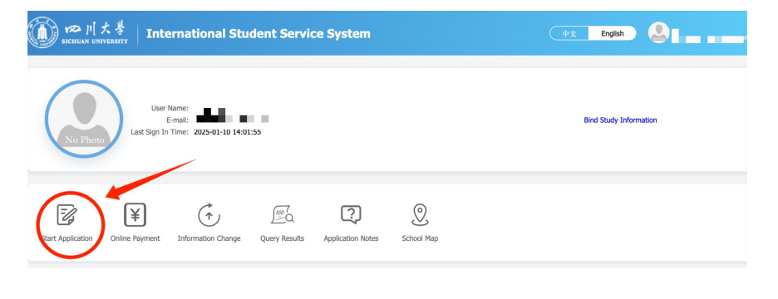
- Click here to agree the regulation and go on to the next step.
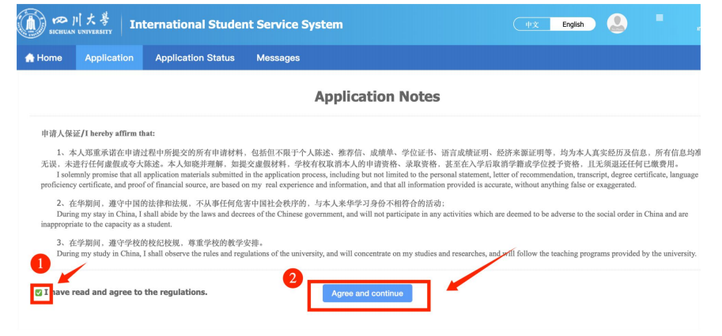

- Choose“Global Link”, and click“Next”.
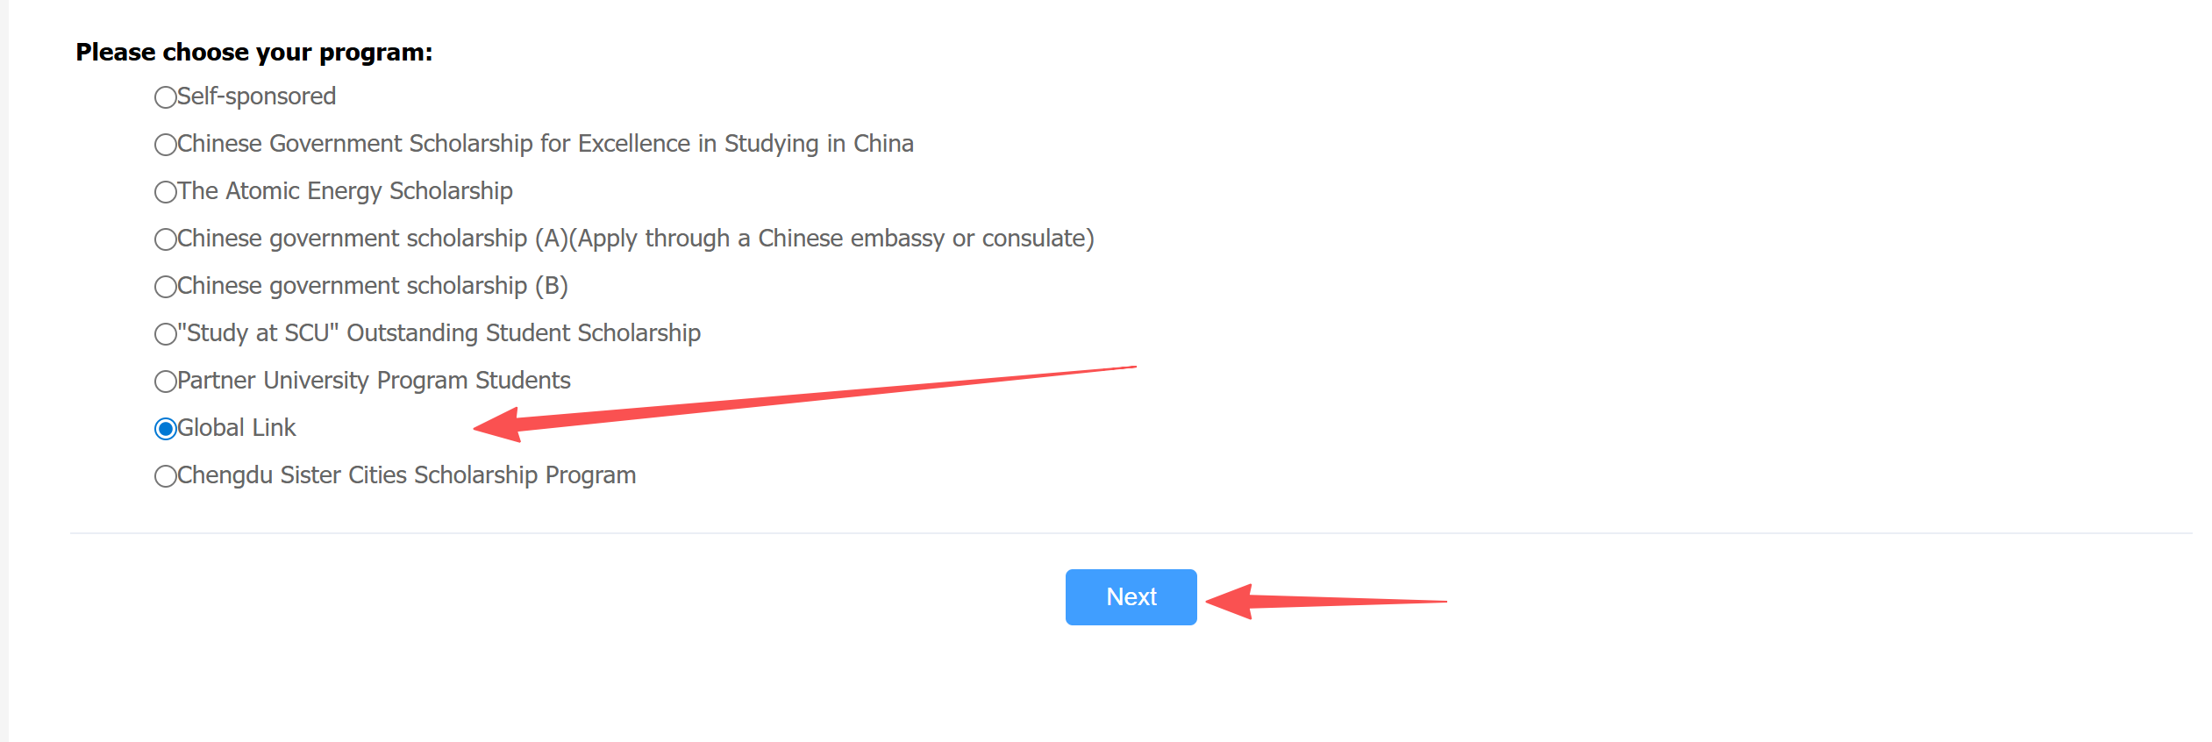

- Click “Apply”
